EENG 385 - Electronic Devices and Circuits

BJT Curve Tracer: Deboo Integrator

Lab Document

# Objective

The objective of the lab is to introduce the operation of the Deboo Integrator and its interactions with the 555 Timer and the Schmitt Trigger Relaxation Oscillator to create a staircase voltage waveform.

# System Architecture

In this third lab of the BJT Curve Tracer, shown in Figure 1, you will explore the Deboo Integrator, a circuit that takes the integral of its input.

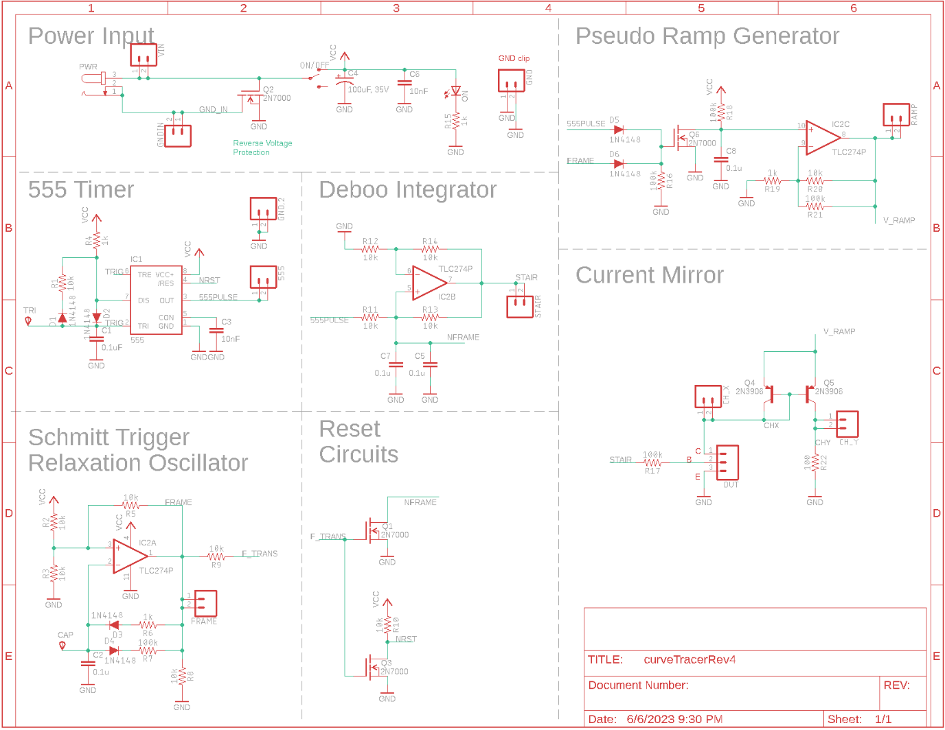

Figure : The complete BJT curve tracer. Note we will only populate 1 of the C5 or C7 0.1uF capacitors in our circuit.

Look carefully at the schematic and locate the Deboo Integrator subsystem. Notice the two signals “555PULSE” and “NFRAME” in this subsystem originate in the 555 Timer and the Schmitt Trigger Relaxation Oscillator (via Reset Circuits) subsystems. In order to understand the behavior of the Deboo Integrator, you should review the behavior of these two subsystems. Do this by retrieving the simulation information you found in the previous two labs and put the information into Table 1. We will come back to this table through the course of the lab.

Table : The output of the 555 Timer and Schmitt Trigger Oscillator simulations from the prior two labs.

|  |  |  |
| --- | --- | --- |
| **Quantity** | **555 Timer Simulation** | **Schmitt Trigger Relax Osc Simulation** |
| Time high (µs) | 39.0 µs | 0.46 ms |
| Time low (µs) | 275 µs | 4.6 ms |
| Period (µs) | 314 µs | 8091 us |
| Frequency (kHz) | 3.18 kHz | 198 Hz |
| Duty Cycle | 8.7% | 9.1% |

# Analysis Deboo Integrator

The construction of a working BJT curve tracer requires we create a staircase-shaped voltage waveform. A staircase waveform looks like, you guess it, a staircase when viewed from the side – you will see it later in the lab. The circuit to do this is a Howland Current Source with a capacitive load, called a Deboo Integrator. The Deboo Integrator to be built is shown in Figure 2. Note, in this circuit all the resistors have the same value, denoted as *R*.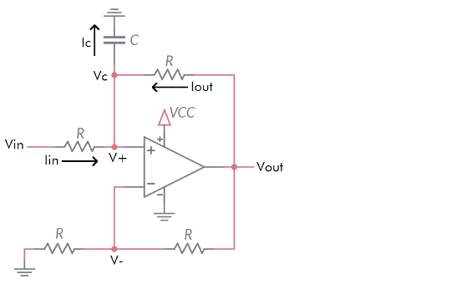

Figure : A Deboo Integrator integrates the input voltage over time.

To understand how the Deboo Integrator computes the integral of the input voltage, let’s walk through the following analysis together.

1. Write an equation relating *V-* and *Vout*. Solve in terms of *Vout* . *(Hint: Voltage divider.)*

***Vout = 2*V-***

1. Write an equation for Iout in terms of V+, *Vout* and *R*. *(Hint: Use Ohm’s law.)*

***(Vout – V+) = IoutR Iout = (Vout – V+) / R***

1. Replace the *Vout* term in the Step 2 equation with the value for *Vout* found in the Step 1 equation.

***Iout = (2*V- – V+) / R***

1. Since the circuit has (circle one) positive/negative **negative** feedback the inverting and non-inverting inputs of the op amp are the same. Let’s call this common voltage *Vc.* So, *V- = V+ = Vc* .
2. Replace *V+* and *V-* in the Step 3 equation with *Vc* and simplify.

***Iout = (2*Vc – Vc) / R = Vc / R***

1. Write an equation for *Iin* in terms of *Vin*, *Vc*, and *R*. *(Hint: Ohm’s law.)*

***(Vin – Vc) = IinR so, Iin = (Vin – Vc) / R***

1. Write a KCL equation for the *V+* node.

***Iout + Iin = Ic***

1. Replace the *Iout* and *Iin* terms in the Step 7 equation with the value for *Iout / Iin*found in the Steps 5/6 equation. Simplify. *(Hint: The simplified equation has three terms.)*

***Vc / R + (Vin – Vc) / R = Ic so, Vin / R = Ic***

1. Write the equation for the current (called *Ic*) in a capacitor in terms of the voltage (called *Vc*) and capacitance.

***Ic = C dVc / dt***

1. Replace the *Ic*term in the Step 9 equation with the value for *Ic* found in the Step 8 equation.

***C dVc / dt = Vin / R***

1. Replace the *Vc*term in the Step 10 equation with the value of *Vc* found in the Step 1 equation (remember that V- equals *Vc* ).

***C dVout  / 2dt = Vin / R***

1. Multiply both side of the Step 10 equation by *dt/C* and then integrate both sides.

***dVout = (2Vin / RC)dt so, Vout(t) = 2 / RC * Integral { Vin (t) } from time 0 to t***

This is pretty cool; we have a circuit computing the integral of the input voltage, multiplied by *2/RC*, and placed the result on its output. Let’s now look at how this capability is used to create a staircase voltage.

# Analysis Deboo Integrator in BJT Curve Tracer

The Deboo Integrator in the BJT Curve Tracer in Figure 1 gets its input from the 555 Timer output pulses (555PULSE in Figure 1). The next set of questions seeks to understand how the Deboo Integrator output will look like when it receives these pulses.

1. Using the values of resistance and capacitance in Figure 1, compute the weighting factor *2/RC* for the Deboo Integrator output. Note, I created the PCB with a parallel combination of 0.1uF capacitors C5 and C7 forms a 0.2uF capacitor. Why not just use a single 0.2uF capacitor? Two words, *inventory management* – it’s easier to manage the inventory of 0.1uF capacitors that are used in all sorts of PCBs, then it is to stock a wide variety of odd-ball capacitor values that are used just once. After a lot of testing, a single 0.1uF works better. **So you will only populate one of C5/C7 positions using a single 0.1uF capacitor.**

**From Figure 1, *R = 6.8k* and *C = 0.1µF*, so *2 / RC = 2,941 / sec* (note weird units)**

1. Assume *Vcc = 9V.* Apply a single 555 Timer pulse from Table 1 to the *Vin* terminal of the Deboo Integrator. How much will *Vout* increase? Remember an integral is the area under the curve and for the 555 Timer pulse, this amount is just the area of the rectangle formed by the pulse. Put this value in the **Analysis** column of Table 2 in the Analysis section at the end of the lab. Hint, you need to multiply by the amplitude of the input.

***Vout(t) = 2/RC * Integral { Vin(t) }* from *time 0* to *t***

***Vout(t) = 2941 * Integral { Vin(t) }* from *0* to *39µs = 1.03V***

1. Assume that the *Vout* of the Deboo Integrator is initially at 0V as shown in the upper graph of Figure 3. The lower graph shows a sequence of pulses from the 555 Timer being applied to the input of the Deboo Integrator. Draw the resulting voltage vs. time graph of the *Vout* .

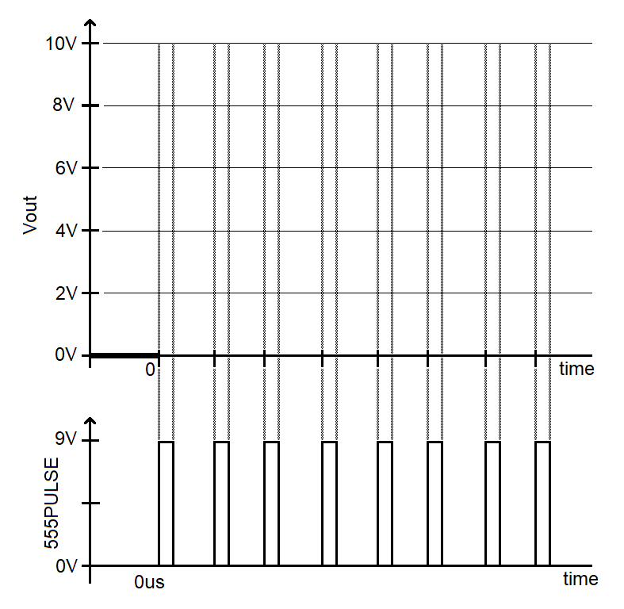

Figure : Complete the Vout curve generated by the Deboo Integrator circuit when the 555 pulse train is applied.

You would be right in concluding the staircase function will only increase as more-and-more 555 timer pulses are applied to its input. To prevent this, we will need a way to periodically remove the charge from the capacitor. We will accomplish this using the frame signal from the Schmitt Trigger Relaxation Oscillator and the Q1 MOSFET shown in Figure 1.

**Resetting the Deboo Integrator Capacitor**

Before diving into the interactions between these modules, let’s take a moment to understand the behavior and purpose of the MOSFET. The 3-terminals of a MOSFET are called the drain (D), gate (G), and source (S). The left side of Figure 4 shows the schematic view of a MOSFET with these terminals labeled.

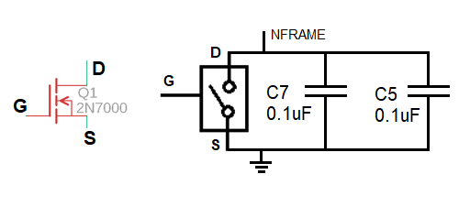

Figure : (Left) The schematic of a MOSFET. (Right) The equivalent circuit of the MOSFET in the Deboo Integrator.

We will remove the accumulated charge on the Deboo Integrator’s pair of capacitors C7 and C5 by using the MOSFET as a voltage-controlled switch, shown on the right side of Figure 4. The behavior of this switch is given by:

* When the gate is driven towards 9V, the switch is closed. In other words, the drain and source are connected.
* When the gate is driven towards 0V, the switch is open. In other words, the drain is disconnected from the source.

Take a moment and look for the Q1 MOSFET in Figure 1.

1. What circuit (subsystem name) is supplying the signal applied to the gate of Q1?

**The Schmitt Trigger Relaxation Oscillator drives the gate of Q1.**

1. During one period, how long is the FRAME signal at 0V and how long is FRAME at 9V? Use the data from Table 1.

**FRAME stays low for 4.6 ms and goes high for 0.46 ms.**

1. How many (integer)555 Timer pulses arrive at the input of the Deboo Integrator while the gate of MOSFET, FRAME, is at 0V? Provide two answers, the fractional answer and this answer rounded down to the nearest integer.

**The 555 Timer has a period of 314 µs. So in 4600 µs there are 4600 µs / 314 µs = 14.6. This will round down to 14 Timer pulses while the FRAME signal is at 0v.**

Now consider how this signal will affect the charge on the capacitor C5 or C7.

1. When the gate of Q1 is driven towards 9V, what will happen to the capacitor C5 or C7? Will it be discharged or allowed to accumulate charge?

**When the gate of Q1 is driven towards 9V, capacitors C5 will be discharged.**

1. When the gate of Q1 is driven towards 0V, what will happen to the capacitor C5 or C7? Will it be discharged or allowed to accumulate charge?

**When the gate of Q1 is driven towards 0V, capacitors C5 will be allowed to charge.**

Now let’s put these ideas together into a picture of how the staircase waveform generated by the Deboo Integrator will look like in the simulator and when assembled.

1. Using the information, calculated in this section, estimate the height of the highest step in the Deboo Integrator output (before the Deboo is reset by the Schmitt Trigger Relaxation Oscillator).

**Since each 555 Timer pulse increases the voltage of the Deboo Integrator by 1.03V, it will take 9V/1.03V = 9 steps to increase the Deboo Integrator output to 9V. Each 555 Timer pulse is 314 µs, so this output will require 9*314 µs = 2.83 ms.**

**The Schmitt Trigger Relaxation Oscillator is at 0V for 4.6ms. For 2.83 ms of this time, the Deboo Integrator output will be “climbing” the stairs. For 4.6 ms – 2.83 ms = 1.77 ms the Deboo Integrator output will be saturated at the top stair.**

Now, with a good understanding of how the Deboo Integrator works, let’s turn to simulating this circuit to check the analysis.

# Simulation Deboo Integrator

Log into your MultiSim Live account and take a moment to verify you have a premium account. If you do not, go to the **Setup a MultiSim Live premium account** instructions in Lab 00 and do this now.

In order to more quickly build the circuit shown Figure 5, you should start by opening the Schmitt Trigger Relaxation Oscillator lab. **Immediately rename the circuit so that you do not accidently overwrite your previous work**. First, spend a few minutes adding in the other circuit elements. You may want to check that the Schmitt Trigger Relaxation Oscillator capacitor has an initial value and that your simulation uses this initial condition. Note, I provided the three probes with their respective test point with names and changed their color in order to make the simulation output more readable – make the 555TIMER test point a light color. Be mindful where you put the probes, their location is important.

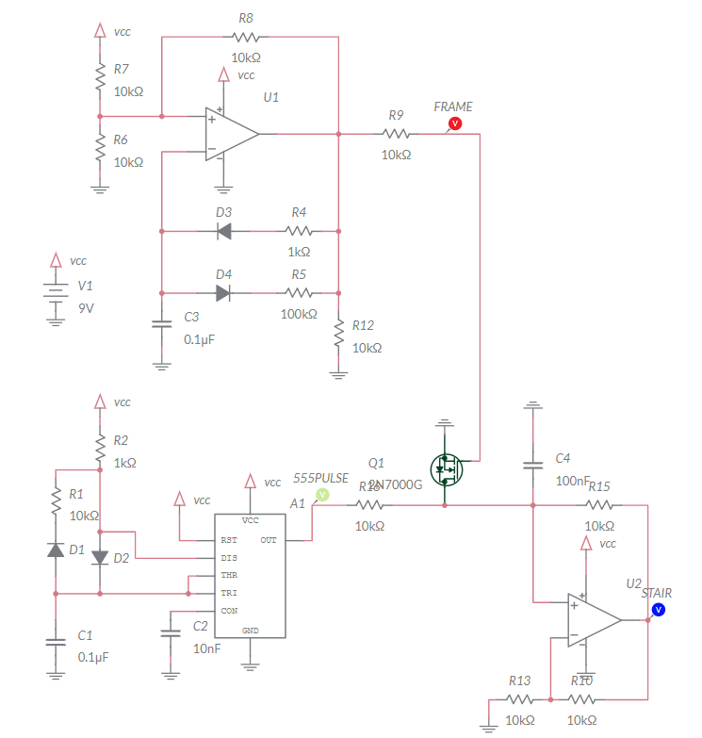

Figure : The Deboo Integrator together with the 555 Timer. Note the single 0.1uF capacitor C4.

The parts list for the Deboo Integrator is the same as for the Schmitt Trigger Relaxation Oscillator with the exception of the 2N7000 MOSFET. You will find this MOSFET in the NMOS submenu in the Transistors part selector.

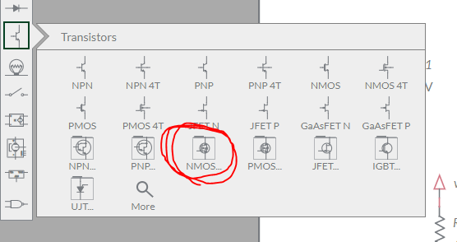

After building the circuit and before running the circuit, you will need to make an unusual change to get the simulator to work. Go to the Document options (double click on the schematic) and find the Simulator options subwindow to the right of the screen. Change the ABSTOL parameter to 1e-8.

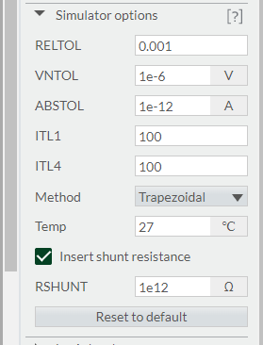

Now run the simulation for 5ms and include the simulated waveform with in your answers. To do this, make sure to select Zoom All and use the Export -> Grapher image from the main menu to produce an output graphic.

Use the simulated staircase waveform to determine the step height. The step height is the amount each 555 Timer pulse increases the voltage on the Deboo Integrator output. Put this value in the *Simulation* column of Table 2 in the Analysis section at the end of the lab.

# Assemble Deboo Integrator

This week, you will be soldering in the components in the Deboo Integrator area of the PCB shown in Figure 6. These components include:

1. The components associated with the DEBOO INTEGRATOR subsystems
2. The Q1 MOSFET, a 2N7000 – *POLARIZED!*
3. The STAIR test point

This week, the MOSFET Q1 is the only polarized part. You will need to bend the leads on the MOSFET to fit the staggered holes of the PCB. Just make sure the flat side of the MOSFET aligns with the flat side of the silk screen outline.

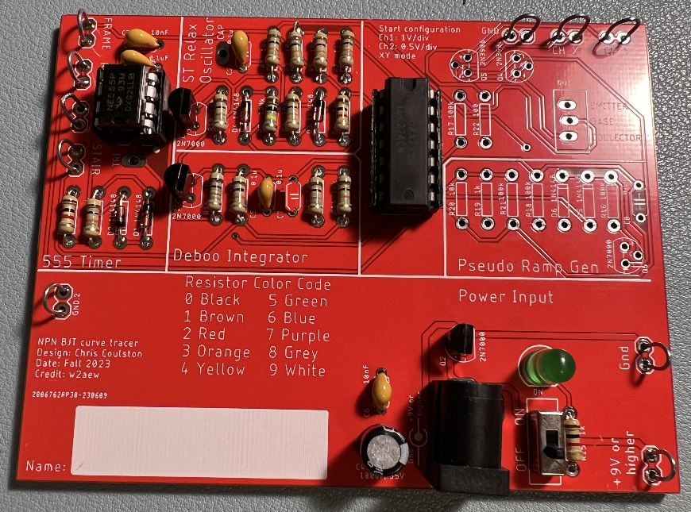

Figure : The completed Deboo integrator. Only populate one of C5 or C7 with a single 0.1uF capacitor. No way did I photoshop capacitor C7 out of the picture.

After you solder in all the components you should test and correct any problems.

**Test ST RELAX OSCILLATOR Subsystem**

1. Check the resistance between the “+9V or higher” and “Gnd” test points with the ON/OFF switch in the OFF position. You should get an overload condition on the DMM – there is essentially infinite resistance with the switch in the OFF position.
2. Check the resistance between the “+9V or higher” and “Gnd” test points with the ON/OFF switch in the ON position. This measurement jumps around and may show negative resistance. The value displayed is not meaningful. You should not get a dead short.
3. Power up the BJT curve tracer:
   * Put the ON/OFF switch in the OFF position.
   * Apply power to the board either through your AC/DC converter or using the lab power supply. If you are using the lab power supply, set the voltage to 9V and the current to 100mA.
   * Set the ON/OFF switch to the ON position.
   * The green LED should illuminate.
4. Power up an oscilloscope Attach a probe to Channel 1 and configure it as follows.

|  |  |
| --- | --- |
| Ch1 probe | 555PULSE test point |
| Ch1 ground clip | GND test point |
| Horizontal (scale) | 100 µs |
| Ch1 (scale) | 1V or 2V (whatever fits better) |
| Ch2 probe | STAIR test point |
| Ch2 (scale) | Same as Channel 1 |
| Trigger mode | Auto |
| Trigger source | Ch2 |
| Trigger slope | ↓ |
| Trigger level | 4.5V |

1. Set the GND reference of Ch1 and Ch2 to the lowest visible reticule. The waveforms will overlap the same as they did in the MultiSim simulation. Set the horizontal position of the trigger to the left most visible reticule. Take a screen shot of this output and include it in your lab report.

After you get everything setup, take a screen shot of the 555PULSE and STAIR waveforms and include in your lab report. Note, the STAIR waveform may be noisy if you use an 110VAC/9VDC converter. For best results, use a lab power supply. Use the data collected from the oscilloscope to determine the step height, that is, the amount each 555 Timer pulse increases the voltage on the Deboo Integrator output. Note, the first step is unreliable, so, measure any of the steps after the first. Put this value in the **Assemble** column of Table 2 in the Analysis section at the end of the lab.

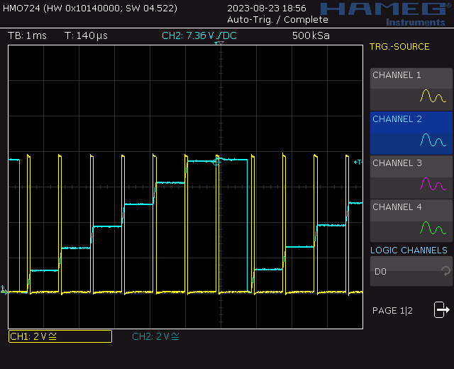

Note, this oscilloscope trace was captured on a Rhode&Schwarz HMO724.

**Debugging Deboo Integrator Subsystem**

I would expect most problems with this subsystem to be the result of:

* Bad solder connection
* Wrong component (resistor or capacitor)

If your BJT curve tracer board fails one of the test steps in the previous section, here is some guidance on what may have happened and how to correct it.

1. If you are getting low resistance with the ON/OFF switch in the off position:
   * Make sure the ON/OFF switch is in the OFF position.
   * Check for solder bridges on the rear of your PCB.
   * Make sure you are reading the DMM correctly. The reading when the ON/OFF switch in the off position should be the same as when you hold the probes apart in air.
2. If you are getting a different resistance with the ON/OFF switch in the ON position:
   * Make sure the ON/OFF switch is in the ON position.
   * Make sure you are reading the DMM correctly. The reading when the ON/OFF switch in the ON position will jump around a lot and probably be negative.
3. If the green LED does not illuminate when power is applied and the ON/OFF switch is in the on position:
   * Test you are applying power. Put a DMM in voltage mode and check the +9V and Gnd test points.
   * Check for solder bridges on the read of the PCB.
4. If you are not getting waveforms resembling the MultiSim Live simulation:
   * Test that the board is powered up.
   * Check the oscilloscope leads are fully inserted.
   * Press the “Default Setup’” button to undo any weird configuration the last user may have left the oscilloscope in.
   * Check that solder connections by trying to wiggle each component. No visible movement should be possible.
   * Check all pins of the TLC274 are firmly engaged into the IC socket.

# Turn In:

1. Make a record of your response to numbered items below and turn in a single copy as your team’s solution on Canvas using the instructions posted there.
2. Include the names of both team members at the top of your solutions.
3. Use complete English sentences to introduce what each of the items listed below is and how it was derived.

**Analysis Deboo Integrator**

Steps 1-12 of analysis

**Analysis Deboo Integrator in BJT Curve Tracer**

Steps 1-9 of analysis

**Simulation Deboo Integrator**

Schematic (use Export -> Schematic Image)

Timing diagram (use Export -> Grapher Image)

**Assemble Deboo Integrator**

Screen shot oscilloscope output for 555PULSE and STAIR.

Table : Summary of the step size calculations made for the Deboo Integrator. If your Deboo Integrators has fewer than 7 steps, leave those rows blank.

|  |  |  |  |
| --- | --- | --- | --- |
| **Quantity** | **Analysis** | **Simulation** | **Assemble** |
| Step size |  |  |  |

|  |  |  |  |
| --- | --- | --- | --- |
| **Steps** | **Analysis** | **Simulation** | **Assemble** |
| 7 | XX XX XX XX |  |  |
| 6 | 9.18 |  |  |
| 5 |  |  |  |
| 4 |  |  |  |
| 3 |  | 4.5 |  |
| 2 |  |  |  |
| 1 |  |  |  |
| 0 | 00 | 0 | 0 |